Roster Verification Tool

Leon County Schools

2015-16

Teacher Instructions

Table of Contents
Overview 2
Objective 2
Login Instructions 2
Reviewing and Modifying Rosters 3
Reviewing your class roster 3
Adding a student to a roster (if necessary) 4
Removing a student from a roster (if necessary) 5
Verifying Rosters 6
Submitting Complete Rosters 7
FAQs 8

Overview
Section 1012.34(8), Florida Statutes requires the State Board of Education to establish a process that permits instructional personnel to review the class roster for accuracy and make corrections relating to the identify of students for whom the individual is responsible. To accomplish this requirement, the Florida Department of Education (FLDOE) has created an online Roster Verification Tool allowing districts, schools, and teachers to view class rosters. Changes can be made and approved as needed through this tool.
In Leon County Schools (LCS), this has historically been handled at the district and school level. Teachers verified and signed rosters, but did not implement any changes or submit rosters with the Roster Verification Tool. Beginning in the 2015-16 school year, teachers that receive a VAM score will edit (if needed) and submit rosters directly from the Roster Verification Tool.
This document contains step-by-step instructions for teacher users to complete the online verification tool and important descriptions and explanations for the different sections of the tool. Teachers will be notified when the tool is open and any associated deadlines.

Objective
Rosters should have a 100% match between Survey 2 – Fall and Survey 3 – Spring. Your objective is to add/remove students if needed in both Survey 2 – Fall and Survey 3 – Spring to ensure that the students listed on the rosters in both surveys match 100%. If they already match without any changes, your objective is to verify and submit the roster.
Survey Dates 2015-2016:
Survey 2 – Fall – October 16, 2015
Survey 3 – Spring – February 12, 2016

You will follow the directions below for BOTH surveys. Begin with Survey 2 – Fall.

Login Instructions
When accessing the Roster Verification Tool, you will be prompted to select an available Survey (Survey 2 – Fall, Survey 3 – Spring) to log into. You will have to log in separately to access each set of data.
Step 1: Obtain login credentials from the Roster Verification Coordinator at your school.
Step 2: Go to the Roster Verification website: https://app3.fldoe.org/RosterVerification/Default.aspx.

Step 3: Click on to access the Fall Roster. Begin with Survey 2 – Fall and then you will go back to follow these steps for Survey 3 – Spring.
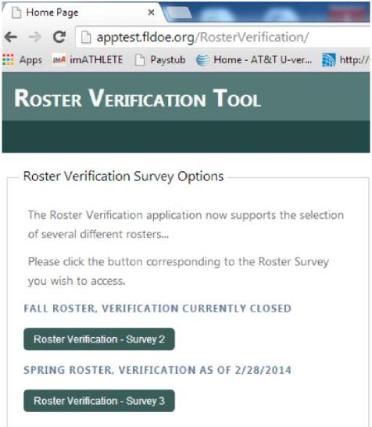
Step 4: Use the default username and password (not case sensitive) when logging in for the first time.
Step 5: Create a new password. Upon initial login, you will be required to create a new password. The new password must be between 8 and 15 characters long and include at least one number. Passwords are not case sensitive.

IMPORTANT TIP: Within the Roster Verification Tool, DO NOT use the back button in your browser. Use the menu buttons at the top of the screen or “Previous Page” to navigate from page to page.
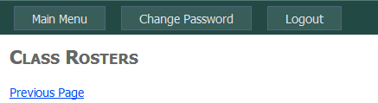

Reviewing and Modifying Rosters
Reviewing your class roster
Step 6: From the Main Menu, click on the first link “Class Rosters.” You will find all of your classes on this page. You can sort the rosters by any of the column headers. For example, if you teach multiple courses, you may want to sort by Course. If you want to go period by period, you can click on Period Begin to make sure they are in numerical order.

Step 7: To open a specific roster for review, click on the Roster link on the list.
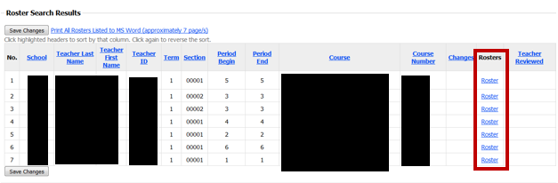

If desired, you can print your rosters so that you can compare them on paper before making any changes in the Roster Verification Tool. To print your roster, click on “Print All Rosters Listed to MS Word” above your list of classes.
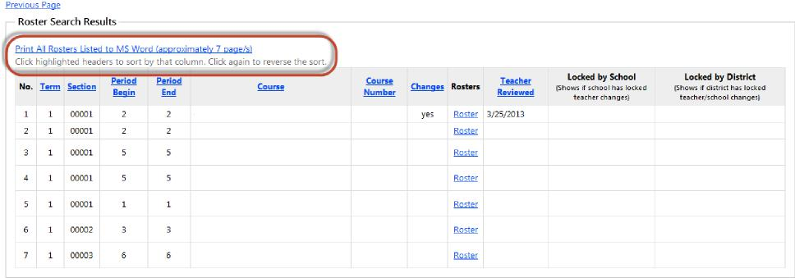

If you do not need to add any students to your roster skip the next section.
Adding a student to a roster
If a student was in your class on the verification date (October 16, 2015 for Survey 2 or February 12, 2015 for Survey 3) and is not listed on your roster in the tool, you may add that student to your roster.
Step A1: Above the roster, there is a section titled “Add Student to Roster.” Click on to see the search criteria.
Select the search criteria to find the student. You may filter on “Student Grade Level,” “Last Name Begins with,” and “First Name Begins with” to locate the student. Click Search Students once you have selected the appropriate criteria.
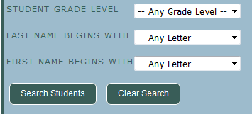
To the right you will now see a list of students at your school that meet your search criteria that can be added to your roster.
Step A2: Select the student you wish to add by clicking the box next to the student’s name and then click View Student Details.

You will now see the student’s name, ID, date of birth, gender, and race to help ensure the appropriate student was selected.
Step A3: If the correct student was selected, click Add Student to Roster.
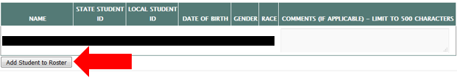
The successfully added student is added to the bottom of your roster and is noted as “pending” until approved by the school coordinator. Changes not approved by the school coordinate will not be taken into account.

If you do not need to add any students to your roster skip the next section.
Removing a student from a roster
If a student is listed on your roster in the tool that was not in your class on the verification date (October 16, 2015 for Survey 2 or February 12, 2016 for Survey 3) or has 10 or more unexcused absences in a semester, you may request to remove that student from your roster.
Step B1: In the column “Remove Student from Roster,” click on the box on the row of the student(s) to be removed. You can select as many students as needed.
Step B2: You may leave comments in the tool to aid your school coordinator in their review of changes. For example, you may want to enter “10 unexcused absences in a semester” to indicate the student is not qualified. Type your comments in the text box at the bottom of the roster review page.
Step B3: Click at the bottom of the roster.
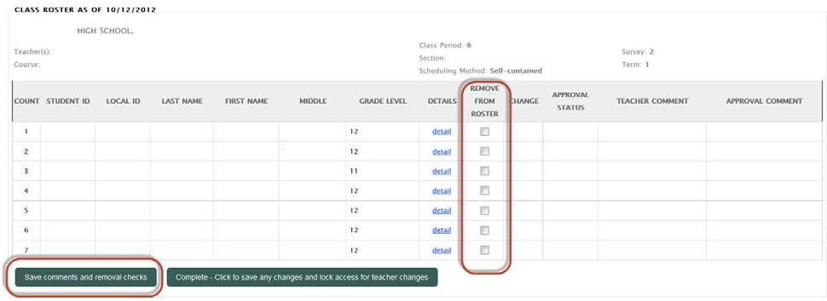
A message will appear at the top of the screen confirming your changes and the students requested for removal will be moved to the bottom of your roster and highlighted in red. The students requested to be removed will remain as “pending” until approved by the school coordinator. Changes that are not approved by the school coordinator will not be taken into account.

Verifying Rosters
Once you have completed making the additions, deletions, and comments on a roster (if needed), you may mark the roster as verified. All changes submitted will still be marked as pending until the school coordinator reviews them.
Step 8: In each roster, click Complete – Click to verify that the roster above is accurate.
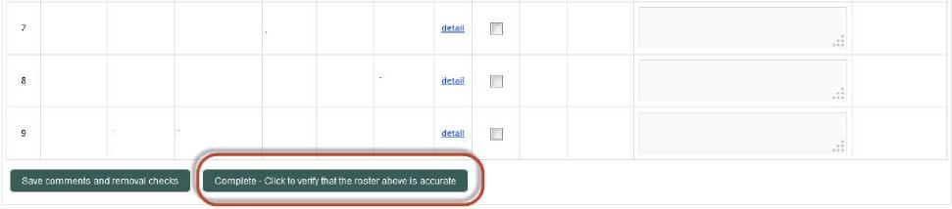
Rosters that have been verified will show a date under the column “Teacher Reviewed.”
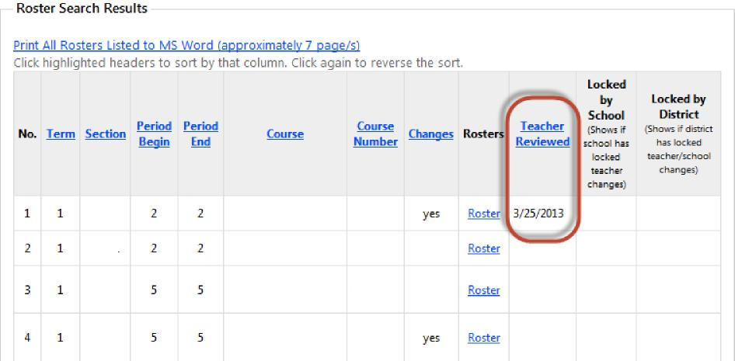

Step 9: Print your finalized rosters for Survey 2 - Fall so that you can use them to match your Survey 3 – Spring rosters. Click on Print All Rosters Listed to MS Word.
Step 10: Return to Step 1 and complete Steps 1-9 for Survey 3 – Spring. Once you have completed Steps 1-9 for Survey 3 – Spring proceed to step 11 below.

Submitting Complete Rosters
Once you have verified all of your rosters, you will need to submit them.
Step 11: Return to the Main Menu by clicking at the top of the screen.
Step 12: Click
Note: All changes made to your rosters will still be marked “pending” until approved by the school coordinator. Clicking “Submit Complete Rosters” will send notice to the school coordinator that you have completed your roster verification process. This will also change your access to read only and you will no longer be able to make changes. If additional changes are required, please contact your school coordinator.

FAQs
I forgot my password. What do I do?
If you have never entered the Roster Verification Tool, contact your school coordinator for your initial setup login credentials.
If you have completed the initial setup, but have now forgotten your password, contact your school coordinator to reset your password.

I teach at more than one school. How do I verify my rosters at both schools?
If you teach at more than one school, Roster Verification Tool will automatically display a menu of those schools that included you in their survey submissions. You may then select each school in turn to verify your rosters. After completing a school, you may either use the URL back arrow at the top left of your browser screen to go back to the school selection menu page for your next school, return to the Main Menu and proceed again from there, or you can logout and login again later to complete all of your schools.

I submitted my roster, but realized I forgot to make a change. What do I do?
Notify your school coordinator so that he/she can make the change.

How do I know if any of my students have been absent for 10 or more days unexcused?
Contact your registrar, APA, or school coordinator for assistance with student attendance.

Whom should I contact for help?
If you need help with changes to your roster or your login, contact your school coordinator.
If you need help with navigating the tool, contact Brett Cucuel by phone (850.487.7870) or email (cucuelb@leonschools.net).

